Open loop signature study

# Purpose

The study logs a comparison between open loop signature in SVI FF R2 (descending from R1 and all the way to AP 3.2.1) and SVI FF R3 (builds C93557 and later).

The primary motivation of changes is behavior on a double-acting springless actuator:

* The test might not complete
* The number of data points collected can be unusably small
* The output (PWM) scan might not sweep the full range of valve position, also applies to single-acting

# Summary of code changes

The material code changes in R3 are as follows:

1. Estimation of bias (PWM output) is still based on in-range closed loop values but moved from expecting stable position/pressure anywhere to expecting stable position at setpoint
2. The total number of samples collected is now bound by the log file size (bug in R2)
3. Data points are not samples while in out-of-range “bias acceleration” area, to allow more useful points to be preserved in the self-pruning buffer.
4. Clamping of bias limits now corresponds to PWM limits
5. Corrected direction change monitoring in waiting for stable position/pressure.

Miscellaneous changes:

1. Added the test step number as a rough indicator to % complete of the process
2. Use (more of) app-specific typedef’ed types
3. Added rounding to integer scaling calculations (intscale32r replaced intscale32)
4. Made a distinction between process failed and process canceled

# Study structure

With three actuators under study (this, this, and this), baseline behavior is established on SVI FF R2. Then the firmware was upgraded to R3 and the same or comparable test repeated. All tests are open loop both ways. Ranges are 5..95%, -2..102% (or -4..104%), 20..80%

# Results summary

On a single-acting, the results are comparable.

On a double-acting without a spring, new code performs significantly better and produces usable results.

On a double-acting with a spring, new code produces more consistent and realistic results.

To look at the supporting tests, use navigation pane in this Word document and toggle between comparable R2 and R3 results

# Known issues

Issues that remain unresolved or partially resolved

1. Signature with out-of-range limits on a double acting may run for a long time, in excess of 25 min
2. In some cases, signature scan may end prematurely, with not all data points collected
3. With out-of-range limits, extreme positions (at stops) sometimes are not reached.

# Study log

## Masoneilan 51/52/53 series actuator.

### Setup

Double-acting springless actuator on the valve.

Supply pressure slightly above 50 psi

## R2

### Date Executed: Feb 25 2022 Start Point 102.00%, End Point -2.00%

Started: 13:23:28

By: 204061827

Location: Anytown

Device Tag: SVI_____________________12120118

Device ID: 0047450008______________12120118

Signature Type: Open Loop

Direction: Both Ways

TB in Manual Mode

Starting Setpoint: 0.37 %

Starting Position: 0.45 %

13:23:29: Supply Pressure: 50.15 psi

13:23:30: The status of final value is initialized.

**13:23:30: Signature 1: Start Point 102.00%, End Point -2.00%**

13:23:30: Supply pressure extremes cleared

13:23:30: IP current extremes cleared

13:57:03: Max Supply Pressure Observed: 51.50 psi

13:57:03: Min Supply Pressure Observed: 36.85 psi

13:57:03: Max Actuator A Pressure Observed: 51.46 psi

13:57:03: Min Actuator A Pressure Observed: 18.34 psi

13:57:03: Max Actuator B Pressure Observed: 28.76 psi

13:57:03: Min Actuator B Pressure Observed: -0.57 psi

13:57:03: Max IP Current Observed: 105.62 %

13:57:03: Min IP Current Observed: 0.35 %

Signature Test cancelled

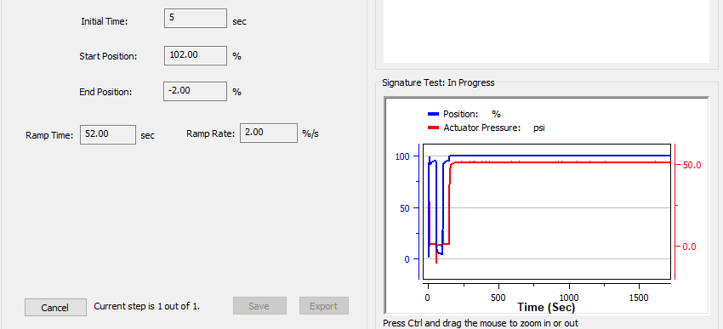

### Date Executed: Feb 25 2022 Start Point 95%, End Point 5%

Started: 16:26:17

By: 204061827

Location: Anytown

Device Tag: SVI_____________________12120118

Device ID: 0047450008______________12120118

Signature Type: Open Loop

Direction: Both Ways

TB in Manual Mode

Starting Setpoint: -12.40 %

Starting Position: 0.26 %

16:26:17: Supply Pressure: 48.71 psi

16:26:18: The status of final value is initialized.

**16:26:18: Signature 1:** **Start Point 95%, End Point 5%**

16:26:18: Supply pressure extremes cleared

16:26:19: IP current extremes cleared

17:00:21: Max Supply Pressure Observed: 51.50 psi

17:00:21: Min Supply Pressure Observed: 36.83 psi

17:00:21: Max Actuator A Pressure Observed: 51.43 psi

17:00:21: Min Actuator A Pressure Observed: -0.36 psi

17:00:21: Max Actuator B Pressure Observed: 48.47 psi

17:00:21: Min Actuator B Pressure Observed: -0.60 psi

17:00:21: Max IP Current Observed: 105.60 %

17:00:21: Min IP Current Observed: 0.23 %

Signature Test cancelled

***Not completed***

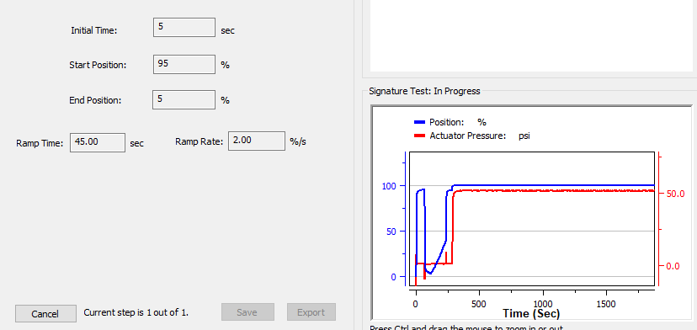

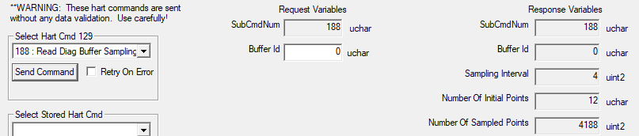

### Date Executed: Feb 28 2022 Start Point 20%, End Point 80%

Started: 23:52:03

By: 204061827

Location: Anytown

Device Tag: SVI_____________________12120118

Device ID: 0047450008______________12120118

Signature Type: Open Loop

Direction: Both Ways

TB in Manual Mode

Starting Setpoint: 13.78 %

Starting Position: 13.86 %

23:52:04: Supply Pressure: 50.13 psi

23:52:04: The status of final value is initialized.

23:52:05: Signature 1: Start Point 20%, End Point 80%

23:52:05: Supply pressure extremes cleared

23:52:05: IP current extremes cleared

23:59:24: Max Supply Pressure Observed: 50.57 psi

23:59:24: Min Supply Pressure Observed: 36.85 psi

23:59:24: Max Actuator A Pressure Observed: 27.36 psi

23:59:24: Min Actuator A Pressure Observed: 17.58 psi

23:59:24: Max Actuator B Pressure Observed: 28.46 psi

23:59:24: Min Actuator B Pressure Observed: 17.74 psi

23:59:24: Max IP Current Observed: 74.70 %

23:59:24: Min IP Current Observed: 0.33 %

23:59:25: Supply pressure extremes restored

23:59:25: IP current extremes restored

23:59:58: Uploading Data - Completed

Number of Points: 1222

Signature Test completed

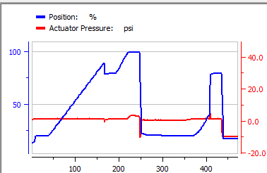

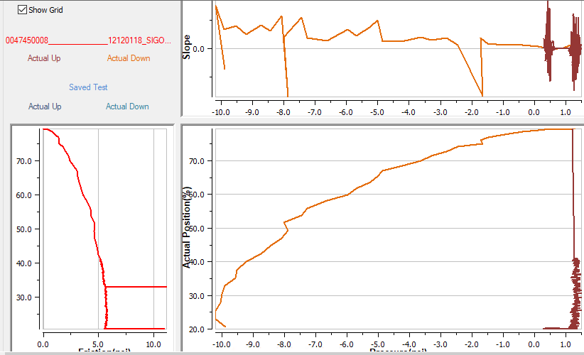

### Date Executed: Mar 01 2022 Start Point -4%, End Point 104%

Started: 00:15:25

By: 204061827

Location: Anytown

Device Tag: SVI_____________________12120118

Device ID: 0047450008______________12120118

Signature Type: Open Loop

Direction: Both Ways

TB in Manual Mode

Starting Setpoint: 14.00 %

Starting Position: 13.92 %

00:15:26: Supply Pressure: 50.07 psi

00:15:26: The status of final value is initialized.

**00:15:27: Signature 1: Start Point -4%, End Point 104%**

00:15:27: Supply pressure extremes cleared

00:15:27: IP current extremes cleared

00:23:32: Max Supply Pressure Observed: 50.65 psi

00:23:32: Min Supply Pressure Observed: 36.95 psi

00:23:32: Max Actuator A Pressure Observed: 33.52 psi

00:23:32: Min Actuator A Pressure Observed: -0.23 psi

00:23:32: Max Actuator B Pressure Observed: 37.96 psi

00:23:32: Min Actuator B Pressure Observed: 18.19 psi

00:23:33: Max IP Current Observed: 104.49 %

00:23:33: Min IP Current Observed: 0.13 %

00:23:33: Supply pressure extremes restored

00:23:33: IP current extremes restored

00:23:57: Uploading Data - Completed

Number of Points: 906

Signature Test completed

**Friction not computed**

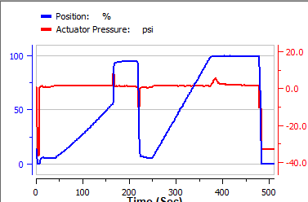

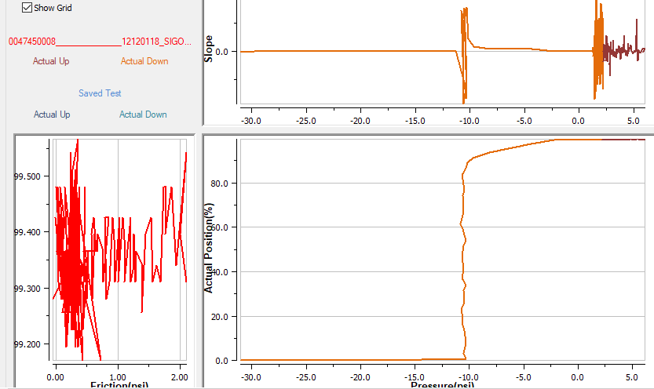

## R3 (C93557)

### Date Executed: Feb 25 2022 Start Point 95%, End Point 5%

Started: 20:22:58

By: 204061827

Location: Anytown

Device Tag: SVI_____________________12120118

Device ID: 4456440008______________12120118

Signature Type: Open Loop

Direction: Both Ways

TB in Manual Mode

Starting Setpoint: 0.97 %

Starting Position: 0.85 %

20:22:59: Supply Pressure: 50.29 psi

20:22:59: The status of final value is initialized.

**20:23:00: Signature 1:** **Start Point 95%, End Point 5%**

20:23:00: Supply pressure extremes cleared

20:23:00: IP current extremes cleared

20:34:14: Max Supply Pressure Observed: 50.87 psi

20:34:14: Min Supply Pressure Observed: 36.93 psi

20:34:14: Max Actuator A Pressure Observed: 28.94 psi

20:34:14: Min Actuator A Pressure Observed: 18.21 psi

20:34:14: Max Actuator B Pressure Observed: 28.39 psi

20:34:14: Min Actuator B Pressure Observed: 17.56 psi

20:34:15: Max IP Current Observed: 104.50 %

20:34:15: Min IP Current Observed: 36.47 %

20:34:15: Supply pressure extremes restored

20:34:15: IP current extremes restored

20:34:34: Uploading Data - Completed

Interval: 240ms

Number of Points in first direction: 508

Number of Points in second direction: 499

Number of Points: 1007

Signature Test completed

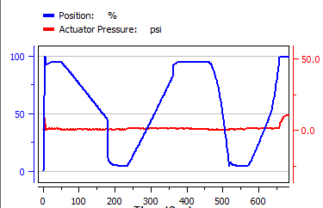

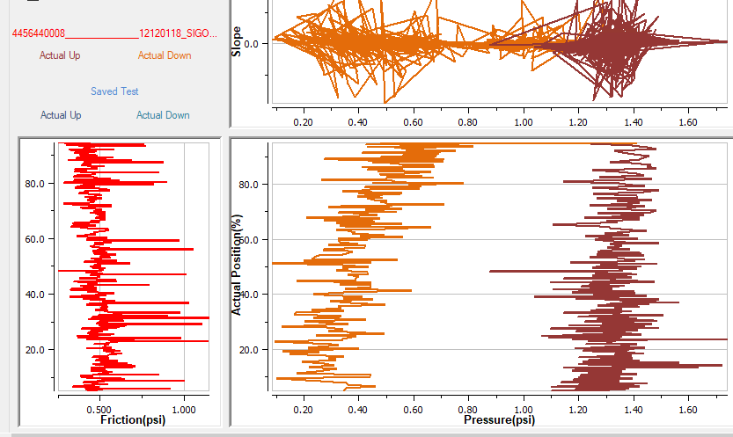

### Date Executed: Feb 25 2022 Start Point 102%, End Point -2%

Started: 20:40:39

By: 204061827

Location: Anytown

Device Tag: SVI_____________________12120118

Device ID: 4456440008______________12120118

Signature Type: Open Loop

Direction: Both Ways

TB in Manual Mode

Starting Setpoint: 104.00 %

Starting Position: 99.48 %

20:40:40: Supply Pressure: 50.33 psi

20:40:40: The status of final value is initialized.

**20:40:41: Signature 1: Start Point 102%, End Point -2%**

20:40:41: Supply pressure extremes cleared

20:40:41: IP current extremes cleared

20:49:18: Max Supply Pressure Observed: 51.32 psi

20:49:18: Min Supply Pressure Observed: 35.60 psi

20:49:18: Max Actuator A Pressure Observed: 50.58 psi

20:49:18: Min Actuator A Pressure Observed: 0.36 psi

20:49:18: Max Actuator B Pressure Observed: 33.79 psi

20:49:18: Min Actuator B Pressure Observed: -0.19 psi

20:49:18: Max IP Current Observed: 71.86 %

20:49:18: Min IP Current Observed: 0.61 %

20:49:18: Supply pressure extremes restored

20:49:18: IP current extremes restored

20:49:42: Uploading Data - Completed

Interval: 60ms

Number of Points in first direction: 439

Number of Points in second direction: 828

Number of Points: 1267

Signature Test completed

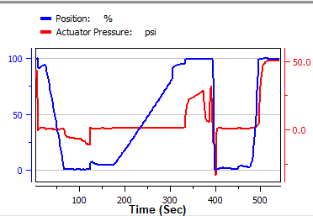

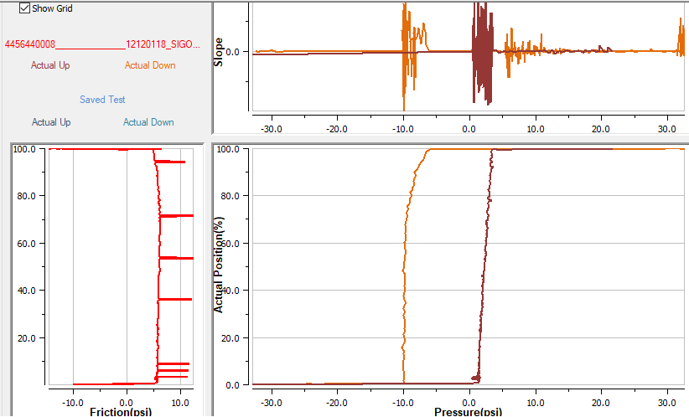

### Date Executed: Feb 25 2022 Start Point -2%, End Point 102%

Started: 20:54:07

By: 204061827

Location: Anytown

Device Tag: SVI_____________________12120118

Device ID: 4456440008______________12120118

Signature Type: Open Loop

Direction: Both Ways

TB in Manual Mode

Starting Setpoint: 112.40 %

Starting Position: 100.05 %

20:54:07: Supply Pressure: 51.47 psi

20:54:08: The status of final value is initialized.

**20:54:08: Signature 1:** **Start Point -2%, End Point 102%**

20:54:08: Supply pressure extremes cleared

20:54:09: IP current extremes cleared

21:00:52: Max Supply Pressure Observed: 51.60 psi

21:00:52: Min Supply Pressure Observed: 35.33 psi

21:00:52: Max Actuator A Pressure Observed: 51.45 psi

21:00:52: Min Actuator A Pressure Observed: -0.47 psi

21:00:52: Max Actuator B Pressure Observed: 45.81 psi

21:00:52: Min Actuator B Pressure Observed: -0.46 psi

21:00:52: Max IP Current Observed: 106.37 %

21:00:52: Min IP Current Observed: 0.55 %

21:00:52: Supply pressure extremes restored

21:00:52: IP current extremes restored

21:01:12: Uploading Data - Completed

Interval: 60ms

Number of Points in first direction: 507

Number of Points in second direction: 539

Number of Points: 1046

Signature Test completed

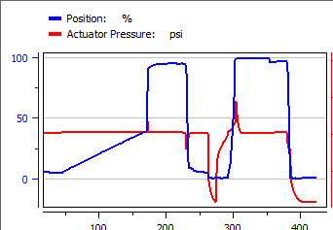

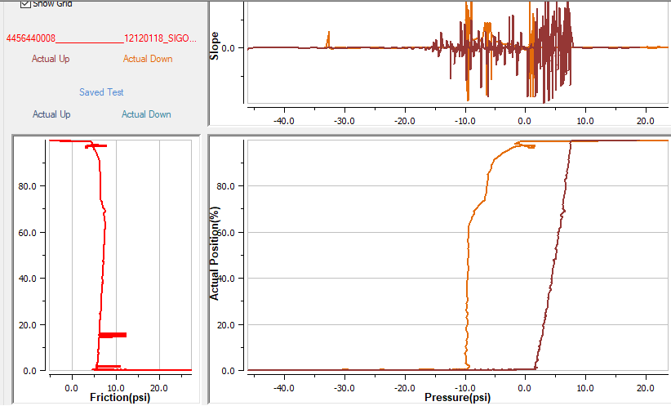

Date Executed: Feb 25 2022

Started: 20:54:07

By: 204061827

Location: Anytown

Device Tag: SVI_____________________12120118

Device ID: 4456440008______________12120118

Signature Type: Open Loop

Direction: Both Ways

TB in Manual Mode

Starting Setpoint: 112.40 %

Starting Position: 100.05 %

20:54:07: Supply Pressure: 51.47 psi

20:54:08: The status of final value is initialized.

20:54:08: Signature 1: Start Point -2%, End Point 102%

20:54:08: Supply pressure extremes cleared

20:54:09: IP current extremes cleared

21:00:52: Max Supply Pressure Observed: 51.60 psi

21:00:52: Min Supply Pressure Observed: 35.33 psi

21:00:52: Max Actuator A Pressure Observed: 51.45 psi

21:00:52: Min Actuator A Pressure Observed: -0.47 psi

21:00:52: Max Actuator B Pressure Observed: 45.81 psi

21:00:52: Min Actuator B Pressure Observed: -0.46 psi

21:00:52: Max IP Current Observed: 106.37 %

21:00:52: Min IP Current Observed: 0.55 %

21:00:52: Supply pressure extremes restored

21:00:52: IP current extremes restored

21:01:12: Uploading Data - Completed

Interval: 60ms

Number of Points in first direction: 507

Number of Points in second direction: 539

Number of Points: 1046

Signature Test completed

****************************************************

### Date Executed: Feb 26 2022 Start Point 5%, End Point 95%

Started: 00:03:51

By: 204061827

Location: Anytown

Device Tag: SVI_____________________12120118

Device ID: 4456440008______________12120118

Signature Type: Open Loop

Direction: Both Ways

TB in Manual Mode

Starting Setpoint: -12.40 %

Starting Position: 0.23 %

00:03:52: Supply Pressure: 48.72 psi

00:03:52: The status of final value is initialized.

**00:03:52: Signature 1:** **Start Point 5%, End Point 95%**

00:03:52: Supply pressure extremes cleared

00:03:53: IP current extremes cleared

00:14:13: Max Supply Pressure Observed: 51.26 psi

00:14:13: Min Supply Pressure Observed: 37.09 psi

00:14:13: Max Actuator A Pressure Observed: 39.47 psi

00:14:13: Min Actuator A Pressure Observed: -0.09 psi

00:14:13: Max Actuator B Pressure Observed: 48.51 psi

00:14:13: Min Actuator B Pressure Observed: 19.02 psi

00:14:14: Max IP Current Observed: 78.72 %

00:14:14: Min IP Current Observed: 3.54 %

00:14:14: Supply pressure extremes restored

00:14:14: IP current extremes restored

00:14:48: Uploading Data - Completed

Interval: 60ms

Number of Points in first direction: 311

Number of Points in second direction: 1526

Number of Points: 1837

Signature Test completed

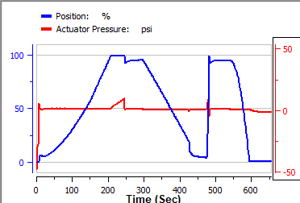

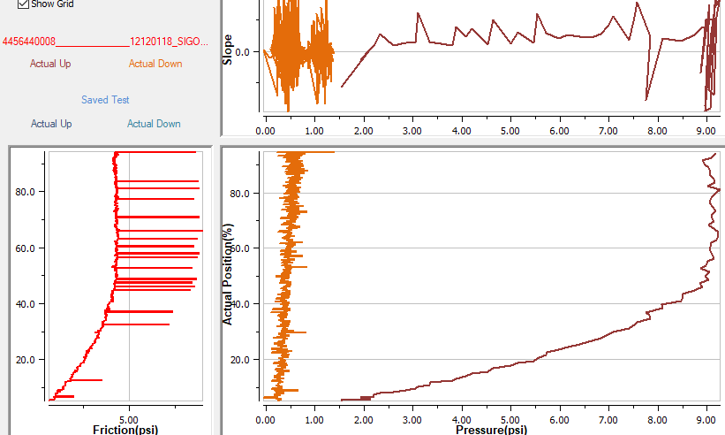

### Date Executed: Feb 28 2022 Start Point 104%, End Point -4%

Started: 21:05:31

By: 204061827

Location: Anytown

Device Tag: SVI_____________________12120118

Device ID: 4456440008______________12120118

Signature Type: Open Loop

Direction: Both Ways

TB in Manual Mode

Starting Setpoint: -0.05 %

Starting Position: 0.57 %

21:05:31: Supply Pressure: 50.66 psi

21:05:31: The status of final value is initialized.

**21:05:32: Signature 1:** **Start Point 104%, End Point -4%**

21:05:32: Supply pressure extremes cleared

21:05:32: IP current extremes cleared

21:15:37: Max Supply Pressure Observed: 51.00 psi

21:15:37: Min Supply Pressure Observed: 37.04 psi

21:15:37: Max Actuator A Pressure Observed: 50.58 psi

21:15:37: Min Actuator A Pressure Observed: 0.63 psi

21:15:37: Max Actuator B Pressure Observed: 37.36 psi

21:15:37: Min Actuator B Pressure Observed: -0.25 psi

21:15:37: Max IP Current Observed: 104.53 %

21:15:37: Min IP Current Observed: 43.17 %

21:15:38: Supply pressure extremes restored

21:15:38: IP current extremes restored

21:16:09: Uploading Data - Completed

Interval: 120ms

Number of Points in first direction: 630

Number of Points in second direction: 543

Number of Points: 1173

Signature Test completed

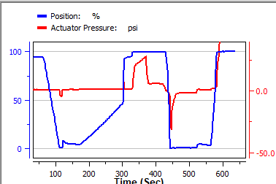

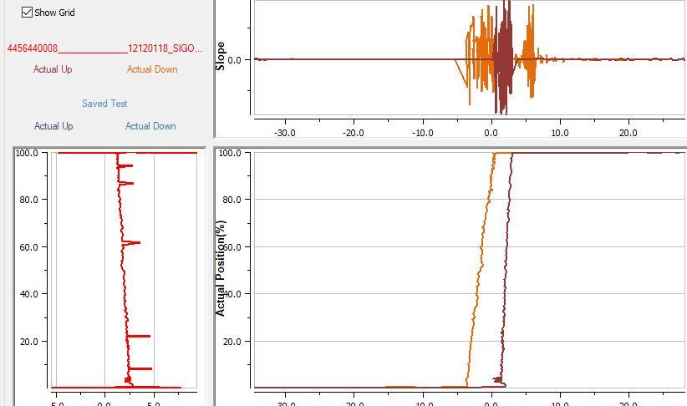

## R3 (C93628)

### Date Executed: Feb 28 2022 Start Point 104%, End Point -5%

Started: 12:32:52

By: 204061827

Location: Anytown

Device Tag: SVI_____________________12120118

Device ID: 4456440008______________12120118

Signature Type: Open Loop

Direction: Both Ways

TB in Manual Mode

Starting Setpoint: -0.02 %

Starting Position: 0.89 %

12:32:53: Supply Pressure: 50.34 psi

12:32:54: The status of final value is initialized.

**12:32:54: Signature 1:** **Start Point 104%, End Point -5%**

12:32:54: Supply pressure extremes cleared

12:32:54: IP current extremes cleared

12:42:52: Max Supply Pressure Observed: 50.92 psi

12:42:52: Min Supply Pressure Observed: 36.98 psi

12:42:52: Max Actuator A Pressure Observed: 50.79 psi

12:42:52: Min Actuator A Pressure Observed: 0.66 psi

12:42:52: Max Actuator B Pressure Observed: 35.27 psi

12:42:52: Min Actuator B Pressure Observed: -0.40 psi

12:42:52: Max IP Current Observed: 104.51 %

12:42:52: Min IP Current Observed: 47.12 %

12:42:52: Supply pressure extremes restored

12:42:52: IP current extremes restored

12:43:23: Uploading Data - Completed

Interval: 120ms

Number of Points in first direction: 630

Number of Points in second direction: 722

Number of Points: 1352

Signature Test completed

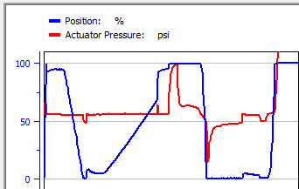

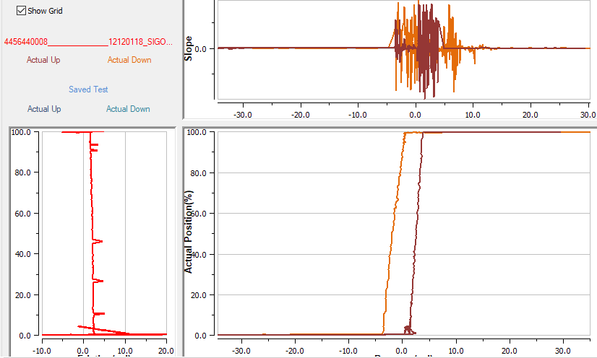

### Date Executed: Feb 28 2022 Start Point 10%, End Point 90%

Started: 13:30:14

By: 204061827

Location: Anytown

Device Tag: SVI_____________________12120118

Device ID: 4456440008______________12120118

Signature Type: Open Loop

Direction: Both Ways

TB in Manual Mode

Starting Setpoint: 114.90 %

Starting Position: 100.05 %

13:30:15: Supply Pressure: 51.40 psi

13:30:16: The status of final value is initialized.

**13:30:17: Signature 1: Start Point 10%, End Point 90%**

13:30:17: Supply pressure extremes cleared

13:30:18: IP current extremes cleared

13:40:19: Max Supply Pressure Observed: 51.51 psi

13:40:19: Min Supply Pressure Observed: 35.39 psi

13:40:19: Max Actuator A Pressure Observed: 51.36 psi

13:40:19: Min Actuator A Pressure Observed: 17.77 psi

13:40:19: Max Actuator B Pressure Observed: 28.41 psi

13:40:19: Min Actuator B Pressure Observed: -0.41 psi

13:40:19: Max IP Current Observed: 104.49 %

13:40:19: Min IP Current Observed: 0.60 %

13:40:19: Supply pressure extremes restored

13:40:20: IP current extremes restored

13:40:47: Uploading Data - Completed

Interval: 240ms

Number of Points in first direction: 816

Number of Points in second direction: 319

Number of Points: 1135

Signature Test completed

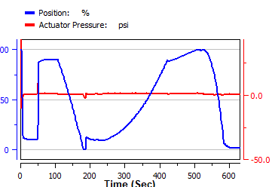

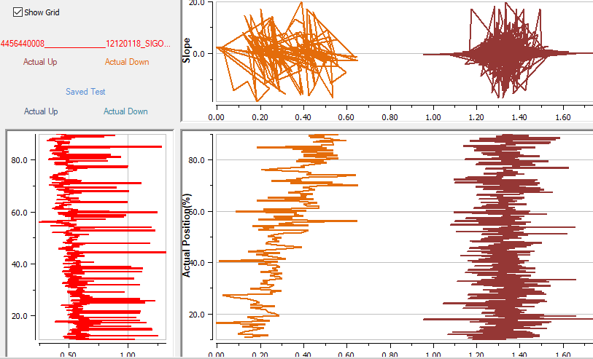

## Morin B-420U-S060 valve

### Setup

Double-acting actuator with a spring on the valve.

Supply pressure about 71 psi

## R2

### Date Executed: Mar 02 2022 Start Point 95%, End Point 5%

Started: 14:35:24

By: 204061827

Location: Anytown

Device Tag: SVI_____________________12120118

Device ID: 0047450008______________12120118

Signature Type: Open Loop

Direction: Both Ways

TB in Manual Mode

Starting Setpoint: 99.55 %

Starting Position: 99.80 %

14:35:25: Supply Pressure: 73.74 psi

14:35:26: The status of final value is initialized.

**14:35:26: Signature 1: Start Point 95%, End Point 5%**

14:35:26: Supply pressure extremes cleared

14:35:26: IP current extremes cleared

14:44:15: Max Supply Pressure Observed: 73.98 psi

14:44:15: Min Supply Pressure Observed: 52.66 psi

14:44:15: Max Actuator A Pressure Observed: 69.52 psi

14:44:15: Min Actuator A Pressure Observed: 49.45 psi

14:44:15: Max Actuator B Pressure Observed: 38.33 psi

14:44:15: Min Actuator B Pressure Observed: 1.72 psi

14:44:15: Max IP Current Observed: 106.45 %

14:44:15: Min IP Current Observed: 0.35 %

14:44:15: Supply pressure extremes restored

14:44:15: IP current extremes restored

14:44:51: Uploading Data - Completed

Number of Points: 1265

Signature Test completed

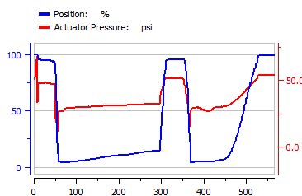

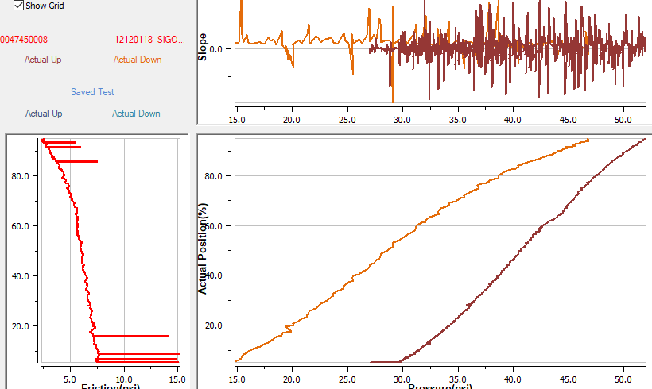

### Date Executed: Mar 02 2022 Start Point 20%, End Point 80%

Started: 14:52:19

By: 204061827

Location: Anytown

Device Tag: SVI_____________________12120118

Device ID: 0047450008______________12120118

Signature Type: Open Loop

Direction: Both Ways

TB in Manual Mode

Starting Setpoint: 104.00 %

Starting Position: 99.88 %

14:52:19: Supply Pressure: 73.43 psi

14:52:20: The status of final value is initialized.

**14:52:20: Signature 1:** **Start Point 20%, End Point 80%**

14:52:20: Supply pressure extremes cleared

14:52:21: IP current extremes cleared

14:59:28: Max Supply Pressure Observed: 73.96 psi

14:59:28: Min Supply Pressure Observed: 51.90 psi

14:59:28: Max Actuator A Pressure Observed: 73.33 psi

14:59:28: Min Actuator A Pressure Observed: 47.44 psi

14:59:28: Max Actuator B Pressure Observed: 37.98 psi

14:59:28: Min Actuator B Pressure Observed: -0.43 psi

14:59:28: Max IP Current Observed: 105.01 %

14:59:28: Min IP Current Observed: 0.18 %

14:59:28: Supply pressure extremes restored

14:59:28: IP current extremes restored

14:59:53: Uploading Data - Completed

Number of Points: 869

Signature Test completed

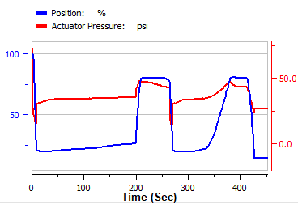

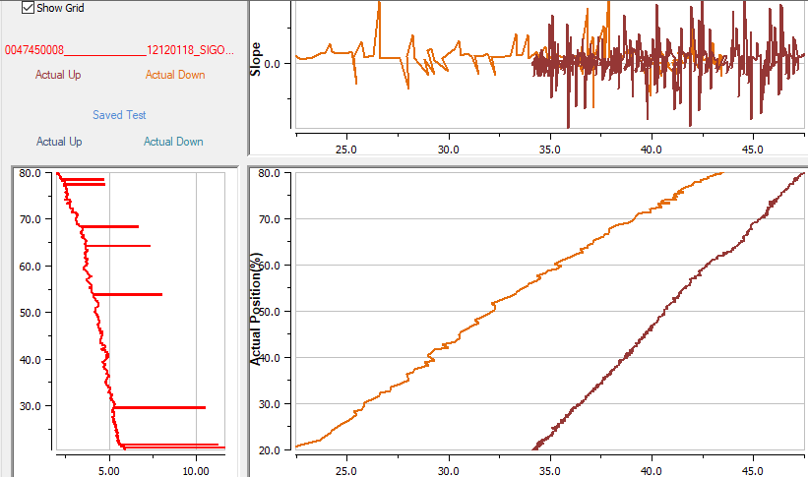

### Date Executed: Mar 02 2022 Start Point 104%, End Point -4%

Started: 21:20:30

By: 204061827

Location: Anytown

Device Tag: SVI_____________________12120118

Device ID: 0047450008______________12120118

Signature Type: Open Loop

Direction: Both Ways

TB in Manual Mode

Starting Setpoint: 14.00 %

Starting Position: 13.96 %

21:20:30: Supply Pressure: 72.92 psi

21:20:31: The status of final value is initialized.

**21:20:32: Signature 1:** **Start Point 104%, End Point -4%**

21:20:32: Supply pressure extremes cleared

21:20:32: IP current extremes cleared

21:26:43: Max Supply Pressure Observed: 74.05 psi

21:26:43: Min Supply Pressure Observed: 52.65 psi

21:26:43: Max Actuator A Pressure Observed: 68.50 psi

21:26:43: Min Actuator A Pressure Observed: -0.33 psi

21:26:43: Max Actuator B Pressure Observed: 58.20 psi

21:26:43: Min Actuator B Pressure Observed: 4.77 psi

21:26:44: Max IP Current Observed: 105.63 %

21:26:44: Min IP Current Observed: 0.16 %

21:26:44: Supply pressure extremes restored

21:26:44: IP current extremes restored

21:26:46: Uploading Data - Completed

Number of Points: 2

Signature Test completed

***DTM doesn’t complete***

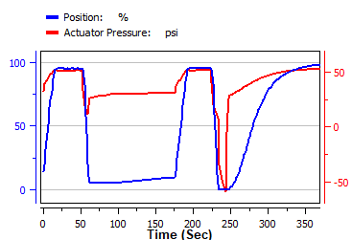

### Date Executed: Mar 02 2022 Start Point 104%, End Point -4%

Started: 21:42:42

By: 204061827

Location: Anytown

Device Tag: SVI_____________________12120118

Device ID: 0047450008______________12120118

Signature Type: Open Loop

Direction: Both Ways

TB in Manual Mode

Starting Setpoint: 114.80 %

Starting Position: 99.90 %

21:42:42: Supply Pressure: 73.61 psi

21:42:43: The status of final value is initialized.

**21:42:44: Signature 1: Start Point 104%, End Point -4%**

21:42:44: Supply pressure extremes cleared

21:42:44: IP current extremes cleared

21:51:19: Max Supply Pressure Observed: 74.24 psi

21:51:19: Min Supply Pressure Observed: 52.86 psi

21:51:19: Max Actuator A Pressure Observed: 73.44 psi

21:51:19: Min Actuator A Pressure Observed: -0.59 psi

21:51:19: Max Actuator B Pressure Observed: 70.87 psi

21:51:19: Min Actuator B Pressure Observed: -0.33 psi

21:51:19: Max IP Current Observed: 105.62 %

21:51:19: Min IP Current Observed: 0.14 %

21:51:19: Supply pressure extremes restored

21:51:20: IP current extremes restored

21:52:33: Uploading Data - Completed

Number of Points: 2753

Signature Test completed

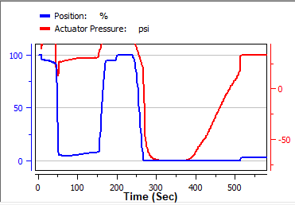

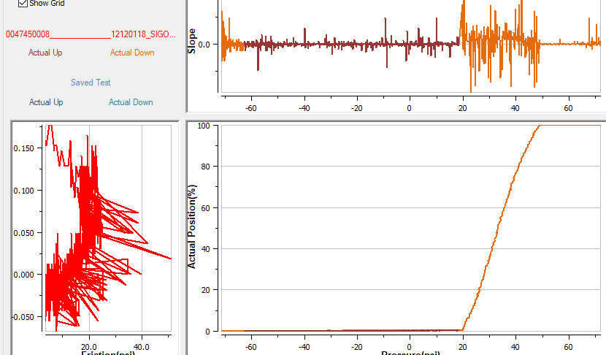

## R3 (C93628)

### Date Executed: Mar 02 2022 Start Point 104%, End Point -4%

Started: 23:00:10

By: 204061827

Location: Anytown

Device Tag: SVI_____________________12120118

Device ID: 4456440008______________12120118

Signature Type: Open Loop

Direction: Both Ways

TB in Manual Mode

Starting Setpoint: 114.80 %

Starting Position: 100.13 %

23:00:11: Supply Pressure: 73.83 psi

23:00:11: The status of final value is initialized.

**23:00:12: Signature 1:** **Start Point 104%, End Point -4%**

23:00:12: Supply pressure extremes cleared

23:00:12: IP current extremes cleared

23:21:55: Max Supply Pressure Observed: 74.31 psi

23:21:55: Min Supply Pressure Observed: 52.90 psi

23:21:55: Max Actuator A Pressure Observed: 73.76 psi

23:21:55: Min Actuator A Pressure Observed: 0.73 psi

23:21:55: Max Actuator B Pressure Observed: 46.47 psi

23:21:55: Min Actuator B Pressure Observed: -0.74 psi

23:21:55: Max IP Current Observed: 106.80 %

23:21:55: Min IP Current Observed: 0.64 %

23:21:55: Supply pressure extremes restored

23:21:56: IP current extremes restored

23:22:18: Uploading Data - Completed

Interval: 240ms

Number of Points in first direction: 730

Number of Points in second direction: 604

Number of Points: 1334

Signature Test completed

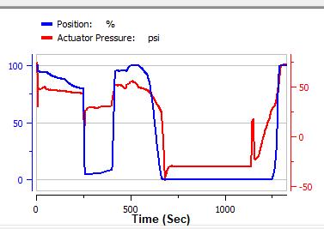

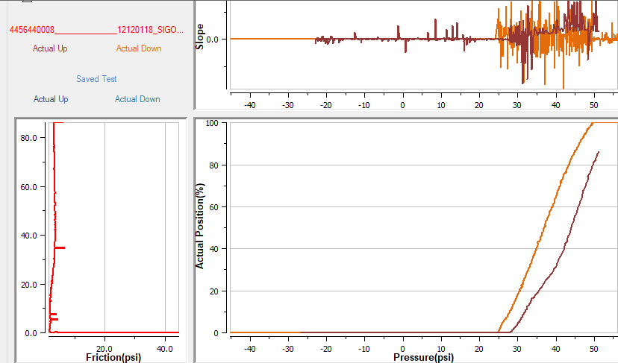

### Date Executed: Mar 02 2022 (#2) Start Point 104%, End Point -4%

Started: 23:31:37

By: 204061827

Location: Anytown

Device Tag: SVI_____________________12120118

Device ID: 4456440008______________12120118

Signature Type: Open Loop

Direction: Both Ways

TB in Manual Mode

Starting Setpoint: 114.80 %

Starting Position: 100.06 %

23:31:37: Supply Pressure: 73.77 psi

23:31:37: The status of final value is initialized.

**23:31:38: Signature 1:** **Start Point 104%, End Point -4%**

23:31:38: Supply pressure extremes cleared

23:31:38: IP current extremes cleared

00:02:42: Max Supply Pressure Observed: 74.34 psi

00:02:42: Min Supply Pressure Observed: 52.78 psi

00:02:42: Max Actuator A Pressure Observed: 73.74 psi

00:02:42: Min Actuator A Pressure Observed: -0.84 psi

00:02:42: Max Actuator B Pressure Observed: 71.36 psi

00:02:42: Min Actuator B Pressure Observed: -0.59 psi

00:02:42: Max IP Current Observed: 105.29 %

00:02:42: Min IP Current Observed: 0.61 %

00:02:42: Supply pressure extremes restored

00:02:42: IP current extremes restored

00:05:14: Uploading Data - Completed

Interval: 480ms

Number of Points in first direction: 576

Number of Points in second direction: 1032

Number of Points: 1608

Signature Test completed

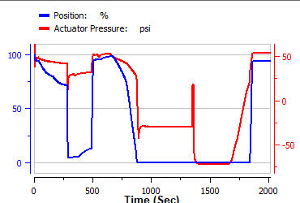

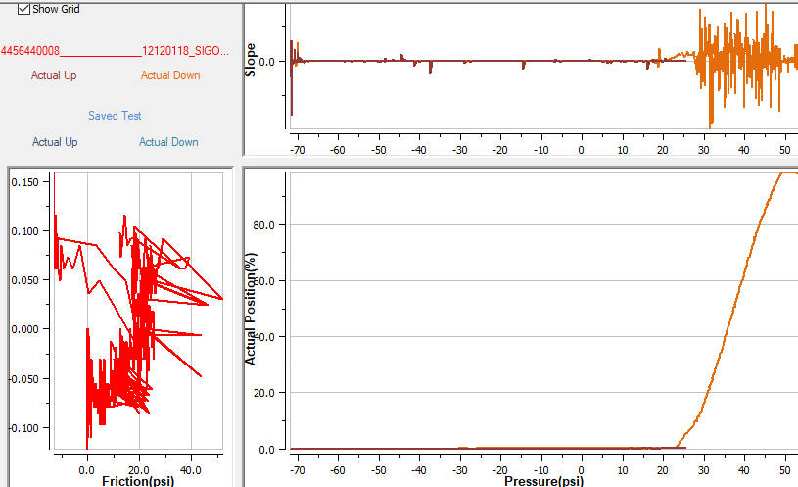

### Date Executed: Mar 03 2022 Start Point 95%, End Point 5%

Started: 12:41:35

By: 204061827

Location: Anytown

Device Tag: SVI_____________________12120118

Device ID: 4456440008______________12120118

Signature Type: Open Loop

Direction: Both Ways

TB in Manual Mode

Starting Setpoint: 114.80 %

Starting Position: 100.05 %

12:41:35: Supply Pressure: 73.77 psi

12:41:35: The status of final value is initialized.

**12:41:36: Signature 1:** **Start Point 95%, End Point 5%**

12:41:36: Supply pressure extremes cleared

12:41:36: IP current extremes cleared

12:52:39: Max Supply Pressure Observed: 74.18 psi

12:52:39: Min Supply Pressure Observed: 52.86 psi

12:52:39: Max Actuator A Pressure Observed: 73.69 psi

12:52:39: Min Actuator A Pressure Observed: 48.69 psi

12:52:39: Max Actuator B Pressure Observed: 37.93 psi

12:52:39: Min Actuator B Pressure Observed: -0.92 psi

12:52:40: Max IP Current Observed: 104.64 %

12:52:40: Min IP Current Observed: 0.63 %

12:52:40: Supply pressure extremes restored

12:52:40: IP current extremes restored

12:53:11: Uploading Data - Completed

Interval: 120ms

Number of Points in first direction: 893

Number of Points in second direction: 1004

Number of Points: 1897

Signature Test completed

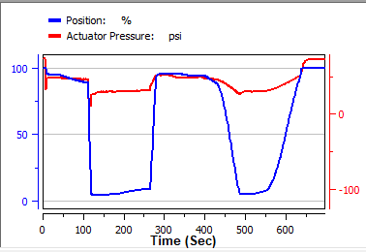

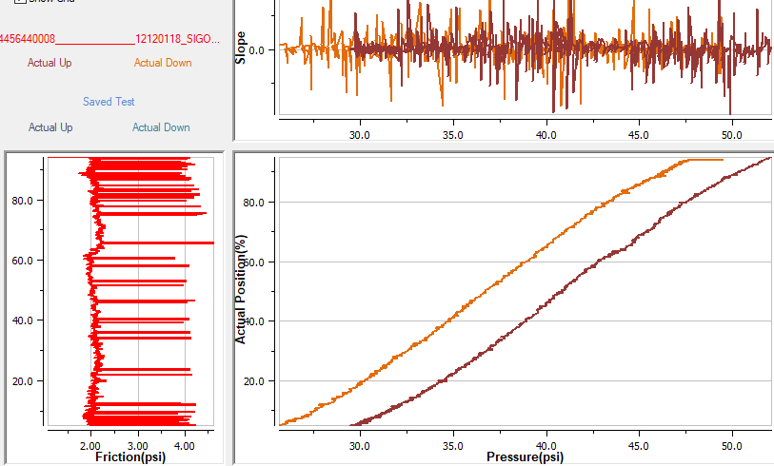

### Date Executed: Mar 03 2022 Start Point 80%, End Point 5%

Started: 13:06:02

By: 204061827

Location: Anytown

Device Tag: SVI_____________________12120118

Device ID: 4456440008______________12120118

Signature Type: Open Loop

Direction: Both Ways

TB in Manual Mode

Starting Setpoint: 104.00 %

Starting Position: 99.98 %

13:06:02: Supply Pressure: 73.63 psi

13:06:02: The status of final value is initialized.

**13:06:03: Signature 1:** **Start Point 80%, End Point 5%**

13:06:03: Supply pressure extremes cleared

13:06:03: IP current extremes cleared

13:19:42: Max Supply Pressure Observed: 74.14 psi

13:19:42: Min Supply Pressure Observed: 51.97 psi

13:19:42: Max Actuator A Pressure Observed: 73.56 psi

13:19:42: Min Actuator A Pressure Observed: 44.91 psi

13:19:42: Max Actuator B Pressure Observed: 35.63 psi

13:19:42: Min Actuator B Pressure Observed: -0.63 psi

13:19:42: Max IP Current Observed: 105.62 %

13:19:42: Min IP Current Observed: 0.67 %

13:19:42: Supply pressure extremes restored

13:19:42: IP current extremes restored

13:20:11: Uploading Data - Completed

Interval: 120ms

Number of Points in first direction: 783

Number of Points in second direction: 948

Number of Points: 1731

Signature Test completed

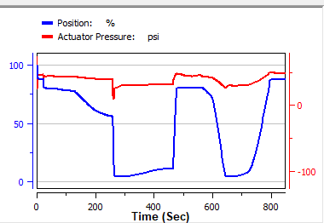

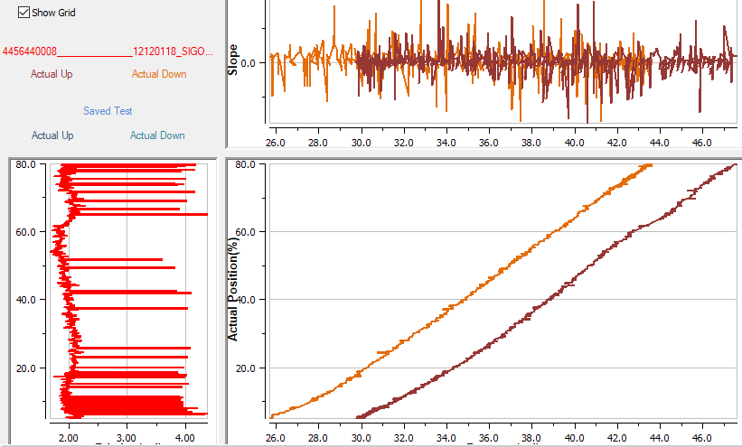

# Single acting ATC

## R2

### Date Executed: Mar 02 2022 Start Point 5.00%, End Point 95.00%

Started: 11:40:34

By: 204061827

Location: Anytown

Device Tag: SVI_____________________09120001

Device ID: 0047450008______________09120001

Signature Type: Open Loop

Direction: Both Ways

TB in Manual Mode

Starting Setpoint: 52.28 %

Starting Position: 52.67 %

11:40:35: Supply Pressure: 25.23 psi

11:40:35: The status of final value is initialized.

**11:40:36: Signature 1: Start Point 5.00%, End Point 95.00%**

11:40:36: Supply pressure extremes cleared

11:40:37: IP current extremes cleared

11:46:02: Max Supply Pressure Observed: 25.44 psi

11:46:02: Min Supply Pressure Observed: 22.48 psi

11:46:02: Max Actuator A Pressure Observed: 24.97 psi

11:46:02: Min Actuator A Pressure Observed: 5.04 psi

11:46:03: Max IP Current Observed: 105.19 %

11:46:03: Min IP Current Observed: 0.10 %

11:46:03: Supply pressure extremes restored

11:46:03: IP current extremes restored

11:46:41: Uploading Data - Completed

Number of Points: 968

Signature Test completed

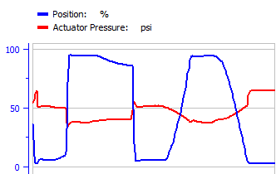

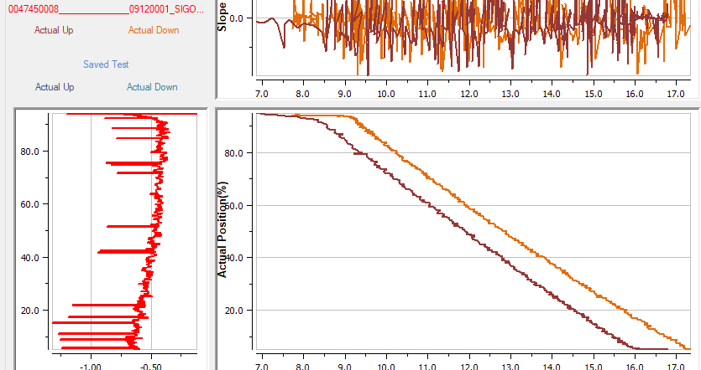

### Date Executed: Mar 02 2022 Point 102.00%, End Point -2%

Started: 11:54:38

By: 204061827

Location: Anytown

Device Tag: SVI_____________________09120001

Device ID: 0047450008______________09120001

Signature Type: Open Loop

Direction: Both Ways

TB in Manual Mode

Starting Setpoint: -4.00 %

Starting Position: 2.72 %

11:54:39: Supply Pressure: 25.56 psi

11:54:40: The status of final value is initialized.

**11:54:40: Signature 1: Start** **Point 102.00%, End Point -2%**

11:54:40: Supply pressure extremes cleared

11:54:41: IP current extremes cleared

12:00:16: Max Supply Pressure Observed: 25.79 psi

12:00:16: Min Supply Pressure Observed: 22.63 psi

12:00:16: Max Actuator A Pressure Observed: 25.64 psi

12:00:16: Min Actuator A Pressure Observed: -0.09 psi

12:00:16: Max IP Current Observed: 105.22 %

12:00:16: Min IP Current Observed: 0.00 %

12:00:17: Supply pressure extremes restored

12:00:17: IP current extremes restored

12:01:04: Uploading Data - Completed

Number of Points: 1179

Signature Test completed

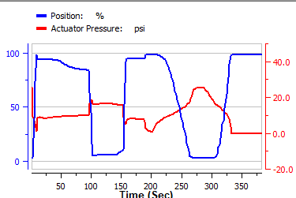

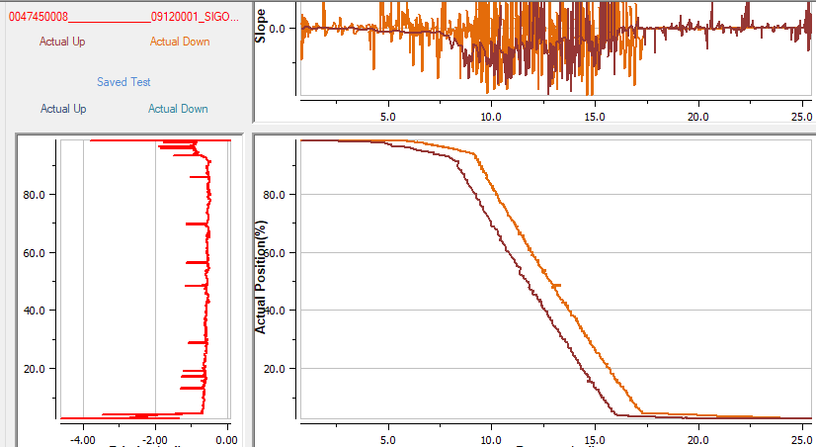

### Date Executed: Mar 02 2022 Start Point 20%, End Point 80%

Started: 13:21:44

By: 204061827

Location: Anytown

Device Tag: SVI_____________________09120001

Device ID: 0047450008______________09120001

Signature Type: Open Loop

Direction: Both Ways

TB in Manual Mode

Starting Setpoint: 112.40 %

Starting Position: 98.58 %

13:21:45: Supply Pressure: 25.02 psi

13:21:45: The status of final value is initialized.

**13:21:46: Signature 1:** **Start Point 20%, End Point 80%**

13:21:46: Supply pressure extremes cleared

13:21:46: IP current extremes cleared

13:29:54: Max Supply Pressure Observed: 25.49 psi

13:29:54: Min Supply Pressure Observed: 21.97 psi

13:29:54: Max Actuator A Pressure Observed: 18.62 psi

13:29:54: Min Actuator A Pressure Observed: -0.20 psi

13:29:54: Max IP Current Observed: 105.21 %

13:29:54: Min IP Current Observed: 0.34 %

13:29:55: Supply pressure extremes restored

13:29:55: IP current extremes restored

13:30:42: Uploading Data - Completed

Number of Points: 1256

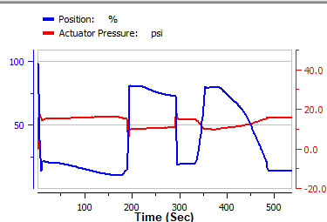

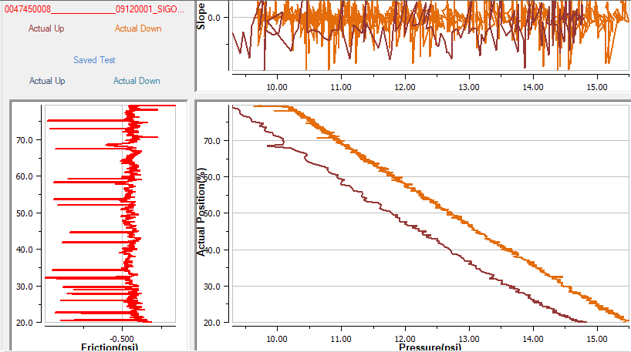

## R3 (C93644)

### Date Executed: Mar 04 2022 Start Point 95%, End Point 5%

Started: 14:53:52

By: 204061827

Location: Anytown

Device Tag: SVI_____________________09120001

Device ID: 4456440008______________09120001

Signature Type: Open Loop

Direction: Both Ways

TB in Manual Mode

Starting Setpoint: 100.07 %

Starting Position: 99.09 %

14:53:53: Supply Pressure: 24.45 psi

14:53:54: The status of final value is initialized.

**14:53:55: Signature 1: Start Point 95%, End Point 5%**

14:53:55: Supply pressure extremes cleared

14:53:55: IP current extremes cleared

15:03:18: Max Supply Pressure Observed: 24.91 psi

15:03:18: Min Supply Pressure Observed: 21.75 psi

15:03:18: Max Actuator A Pressure Observed: 17.66 psi

15:03:18: Min Actuator A Pressure Observed: -2.59 psi

15:03:18: Max IP Current Observed: 105.32 %

15:03:18: Min IP Current Observed: 0.47 %

15:03:19: Supply pressure extremes restored

15:03:19: IP current extremes restored

15:04:03: Uploading Data - Completed

Interval: 120ms

Number of Points in first direction: 888

Number of Points in second direction: 654

Number of Points: 1542

Signature Test completed

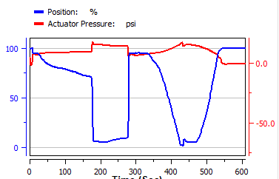

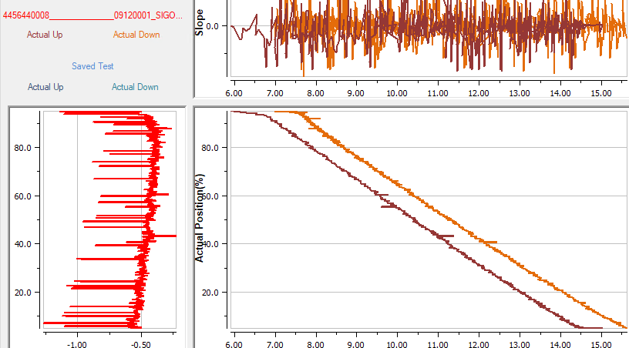

### Date Executed: Mar 04 2022 Start Point 5%, End Point 95%

Started: 20:07:26

By: 204061827

Location: Anytown

Device Tag: SVI_____________________09120001

Device ID: 4456440008______________09120001

Signature Type: Open Loop

Direction: Both Ways

TB in Manual Mode

Starting Setpoint: 14.00 %

Starting Position: 14.06 %

20:07:26: Supply Pressure: 24.34 psi

20:07:27: The status of final value is initialized.

**20:07:27: Signature 1: Start Point 5%, End Point 95%**

20:07:27: Supply pressure extremes cleared

20:07:27: IP current extremes cleared

20:18:31: Max Supply Pressure Observed: 25.07 psi

20:18:31: Min Supply Pressure Observed: 21.65 psi

20:18:31: Max Actuator A Pressure Observed: 24.13 psi

20:18:31: Min Actuator A Pressure Observed: 3.28 psi

20:18:31: Max IP Current Observed: 91.72 %

20:18:31: Min IP Current Observed: 0.55 %

20:18:32: Supply pressure extremes restored

20:18:32: IP current extremes restored

20:19:12: Uploading Data - Completed

Interval: 120ms

Number of Points in first direction: 620

Number of Points in second direction: 767

Number of Points: 1387

Signature Test completed

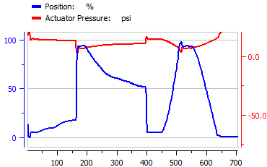

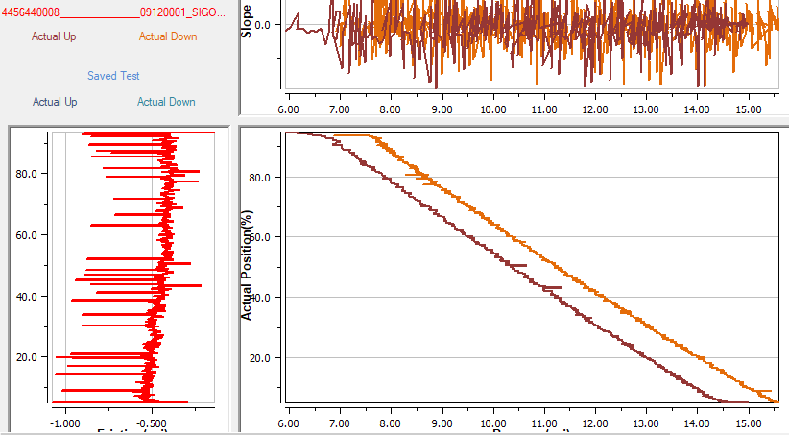

### Date Executed: Mar 04 2022 Start Point 102%, End Point -2%

Started: 19:33:03

By: 204061827

Location: Anytown

Device Tag: SVI_____________________09120001

Device ID: 4456440008______________09120001

Signature Type: Open Loop

Direction: Both Ways

TB in Manual Mode

Starting Setpoint: 104.00 %

Starting Position: 99.91 %

19:33:03: Supply Pressure: 24.48 psi

19:33:04: The status of final value is initialized.

**19:33:05: Signature 1: Start Point 102%, End Point -2%**

19:33:05: Supply pressure extremes cleared

19:33:06: IP current extremes cleared

19:43:19: Max Supply Pressure Observed: 25.15 psi

19:43:19: Min Supply Pressure Observed: 21.67 psi

19:43:19: Max Actuator A Pressure Observed: 24.31 psi

19:43:19: Min Actuator A Pressure Observed: -2.61 psi

19:43:19: Max IP Current Observed: 62.27 %

19:43:19: Min IP Current Observed: 0.45 %

19:43:19: Supply pressure extremes restored

19:43:19: IP current extremes restored

19:44:09: Uploading Data - Completed

Interval: 60ms

Number of Points in first direction: 1288

Number of Points in second direction: 555

Number of Points: 1843

Signature Test completed

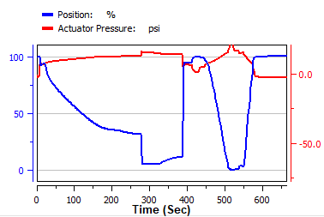

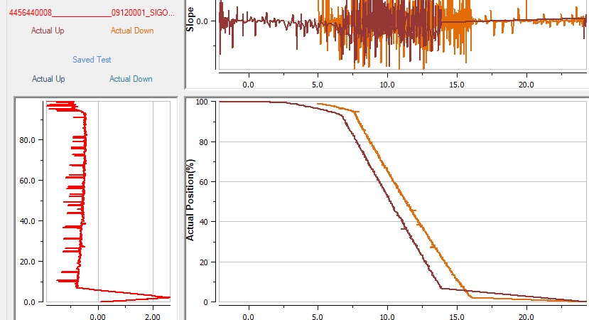

### Date Executed: Mar 04 2022 Start Point 20%, End Point 80%

Started: 19:50:07

By: 204061827

Location: Anytown

Device Tag: SVI_____________________09120001

Device ID: 4456440008______________09120001

Signature Type: Open Loop

Direction: Both Ways

TB in Manual Mode

Starting Setpoint: 112.40 %

Starting Position: 100.02 %

19:50:08: Supply Pressure: 24.18 psi

19:50:09: The status of final value is initialized.

**19:50:09: Signature 1: Start Point 20%, End Point 80%**

19:50:09: Supply pressure extremes cleared

19:50:10: IP current extremes cleared

20:01:17: Max Supply Pressure Observed: 24.93 psi

20:01:17: Min Supply Pressure Observed: 20.88 psi

20:01:17: Max Actuator A Pressure Observed: 17.33 psi

20:01:17: Min Actuator A Pressure Observed: -2.37 psi

20:01:17: Max IP Current Observed: 105.33 %

20:01:17: Min IP Current Observed: 0.54 %

20:01:18: Supply pressure extremes restored

20:01:18: IP current extremes restored

20:01:49: Uploading Data - Completed

Interval: 120ms

Number of Points in first direction: 394

Number of Points in second direction: 659

Number of Points: 1053

Signature Test completed

